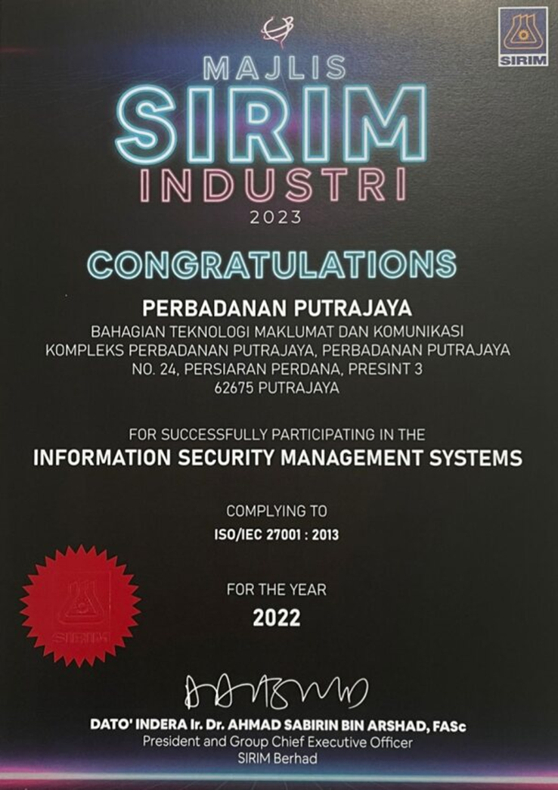

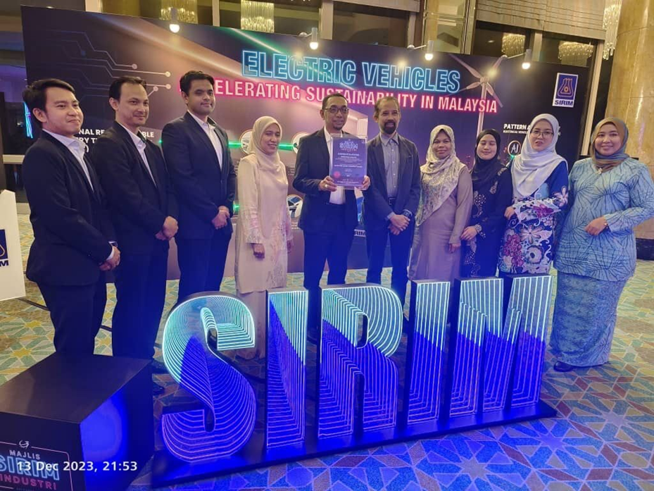

Majlis SIRIM Industri 2023 Bahagian Teknologi Maklumat dan Komunikasi Perbadanan Putrajaya for successfully participating in the Information Security Management Systems (ISO/IEC 27001:2013)