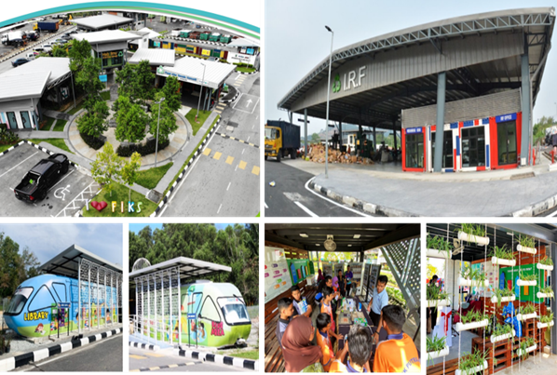

*Anugerah Special Mention Winner*

*Fasiliti Inovasi Kitar Semula Putrajaya (FIKS)*

*Category 5: Indoor Space (Subcategory 1: Public Sector)*