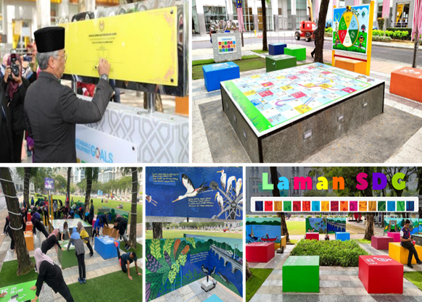

Anugerah Special Mention Winner
Laman SDG Putrajaya
Category 4: Outdoor Space (Subcategory 1: Public Sector)

