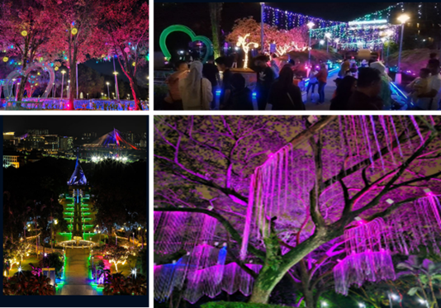

*Anugerah Sapphire Winner*

*Taman Cahaya Putrajaya Category 2: City and Town Park (Subcategory 1: Below 50 Hectares)*