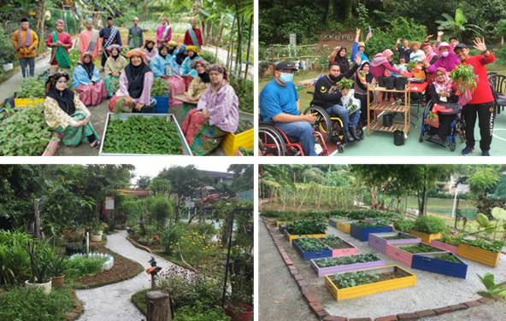

*Anugerah Diamond Winner*

*Kebun Komuniti Bandar Presint 16*

*Category 7: Urban Farming (Subcategory 1: Local Council-Led)*